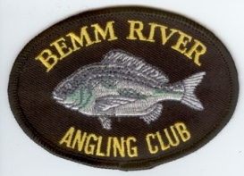
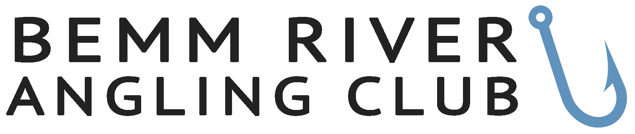

MEMBERSHIP NOTICE 2026

Membership Fees:
Single $20.00 per year
Family $35.00 per year (includes junior children under 16 years)
Junior Free under 16 years on 1 January 2026

To renew your membership or to join the Bemm River Angling Club Inc (BRAC) please complete the form below and return it to Bemm River Angling Club by email to bemmriverangling@gmail.com and deposit the money to the Commonwealth Bank Orbost Branch BSB 063731 ACC 101 360 74 in the name of Bemm River Angling Club Inc making sure your name is in the Description appearing on their statement. This form may also be given to a committee member with the payment.

Name:
Address:
Town and Post Code:
Mobile
E-Mail Address:
Type of Membership  (Please tick appropriate  box)  Family members please complete the list of members and indicate Juniors under the age of 16 years on January 1 2026. | Single Yearly  Family Yearly  Junior  ………………………Mobile………………..  ……………………… Mobile ……………….  ……………………… Mobile ……………….  ……………………………………………….  ………………………………………………..

By joining the Bemm River Angling Club (BRAC), the member agrees to follow club rules and accepts full responsibility for any risks involved in club activities. The member also agrees to indemnify the club against any claims, injuries, losses, or damages suffered by themselves, their family members, guests, or property while participating in club activities.
Junior Members will require their parent or guardian to sign below and must accompany the junior member at all times during BRAC activities.

NAME IN FULL: SIGNED:

Social Media Disclaimer. BRAC may use your photos of fish caught on our social media platforms. If you wish to exclude Juniors included in the membership please indicate below.

