

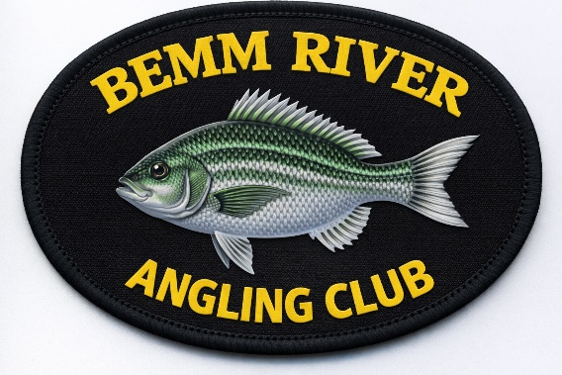

ANGLING COMPETITIONS BY-LAWS AND

COMPETITION RULES
COMPETITION RULES

ELIGIBILITY TO COMPETE IN CLUB COMPETITIONS
(a) Competitions shall be open to all financial & life members of the Bemm River Angling Club Inc (BRAC).
(b) A member who is not financial at the date of an angling competition cannot be awarded any rewards in respect to the competition.
(c) A member shall not be eligible to compete if it has been found that they have submitted fish for a competition via the SMS portal that has been caught outside of the competition hours and or nominated fishing zone specified for that event. The member will be disqualified from that competition.

ANGLING METHOD
(a) Fish shall be taken by rod or line only with no assistance other than netting. Juniors can be assisted, but they must play a majority role in capturing the fish.
(b) A competitor shall not receive assistance of any kind in casting, hooking & playing of a fish. The exception to this rule is made for Juniors only; they may receive help at any time during the fishing competition.
(c) Blue-water fishing includes surf and ocean.
(d) Members must abide by the Fisheries rules and regulations
(e) Members themselves are responsible for obtaining the angling licenses required and are responsible for observing all local regulations.
f) Apart from using a landing net to LAND a fish that has been caught, any other form of netting fish will not be recognized by the club.

COMPETITION EVENTS
The species included in each competition will be specified in the notice of competition on the BRAC Facebook page and or the web site. Normally there will be prizes for the biggest bream, and secret weight prizes. On each day of competition, an angler can only submit one fish of each species but can on subsequent days submit another fish of each species. All fish must be measured on a certified brag mat.
ANNUAL BIGGEST FISH COMPETITIONS
At any time during the year, a member can submit a fish for the biggest fish of the year. The fish must be caught in Bemm River, Sydenham Inlet or from the adjoining beaches. All fish must be photographed with your GPS location turned on using a certified brag mat and that photo sent to the Weigh Master’s portal (0429 411 530). The competition is for the following species:
Bream
Flathead
Estuary Perch
Salmon
CERTIFIED BRAG MAT
(a) Any brag mat can be used as long as it has been certified by the club. The brag mat must have been certified by the club prior to the first competition you fish. A certification will be applied to your mat near the zero line. In some cases, subsequent certification may be accepted as determined by the Weigh Master.
(b) It is up to the angler to maintain the integrity of this certification, so if it's not legible, please get it recertified.
(c) Brag Mat certification can be done at 25 Sydenham Inlet Rd Bemm River prior to each competition. For the annual largest fish competition, arrangement can be made with the Weigh Master.
(d) All fish measurements will be taken to the lowest point on any scale shown on the mat.
Eg. If a fish measures greater than 35cm but less than 36cm and the scale of the brag mat is 1cm increments then the fish will be deemed 35cm. If the brag mat increments are 0.5cm, and the fish measures just over 35.5cm in length but under 36cm, then it will be recorded as 35.5cm

UNIQUE COMPETITION CODE
Before the start of competition, a unique code may be issued via SMS to all registered anglers. This unique code MUST be displayed on the brag mat when photographing any fish you wish to submit.

PHOTO SUBMISSIONS
Photographs of fish can be submitted for club competitions
(a) A photo of each fish must be taken on a certified brag mat.
(b) The fish's mouth must be on the zero line of the brag mat, and the fish's length will be taken to the tip of the tail. No distortion of the fish to gain extra length is allowed. If distortion of the fish is found, then that fish and the angler's entire bag will be disqualified for that competition. Fish will be measured as per Victorian Fisheries Guidelines for measuring. No crease in the mat should be evident and any crease in the mat may lead to disqualification.
(c) At the end of each day’s fishing, your best fish of each species can be submitted to the club’s SMS Portal.
(d) All fish must meet the minimum club length which is 30 cm for bream, estuary perch, salmon and flathead.
(e) If a fish in a photo is deemed to be under size, the angler will be disqualified from the competition.
(f) The fish can be alive when photographed on the club-certified brag mat. Once you have your photograph, the fish can be released or killed and kept.

ADVERSE WEATHER
(a) In competitions, the weigh master and the senior executive committee member present will act conjointly as an adverse weather committee. Their declared decision will be final and binding on all competitors.
(b) However, if the adverse weather committee cannot arrive at a decision, the opinion of the most senior executive committee member will prevail.
INDEMNITY

- By joining the Bemm River Angling Club (BRAC), the member agrees to follow club rules and accepts full responsibility for any risks involved in club activities. The member also agrees to indemnify the club against any claims, injuries, losses, or damages suffered by themselves, their family members, guests, or property while participating in club activities.

- Any member shall be liable to the Club for any damage to or loss of property belonging to the Club through the negligence or malice of that member.

JUNIOR MEMBERS
Junior members must be accompanied at all times by a parent or nominated guardian at all the Bemm River Angling Club (BRAC) events and activities.

